OBJECTIVE: To conduct a correct short field landing..

ELEMENTS:

- How to determine landing performance and limitations.
- Configuration and trim.
- Proper use of pitch and power to maintain desired approach angle.
- Barriers and other hazards which should be considered.
- Effect of wind.
- Selection of touchdown and go-around points.
- A stabilized approach at the recommended airspeed to the selected touchdown point.
- Coordination of flight controls.
- A precise ground track.
- Timing, judgment, and control technique during roundout and touchdown.
- Directional control after touchdown.
- Use of brakes.
- Use of checklist.

SCHEDULE: Pre-flight instruction: 10 Minutes
Travel to training area: 10 Minutes
Instructor Demonstration: 10 Minutes
Student Practice: 30 Minutes
Return from practice area: 10 minutes
Post-flight Review: 10 Minutes
Total Time: 1:20

EQUIPMENT: Functional aircraft.

INSTRUCTOR’S ACTIONS: A. Conduct preflight training on the elements of a short field landing.
B. Demonstrate short field landing.
C. Conduct post flight briefing.

STUDENT’S ACTIONS: A. Ask questions, review homework.
B. Perform preflight.
C. Observe demonstrations.
D. Perform landing IAW PTS.

COMPLETION STANDARDS: Student performs each landing IAW the PTS.

COMMON ERRORS: A. Improper use of performance data and limitations.
B. Failure to establish the approach or landing configuration at the appropriate time or in the proper sequence.
C. Failure to establish and maintain a stabilized approach.
D. Improper technique in use of power, flaps and trim.
E. Inappropriate removal of hand from throttle.
F. Improper techniques during roundout and touchdown.
G. Poor directional control after touchdown.
H. Improper use of brakes.
Introduction: The object of a short field landing is to come in as slow as possible with as steep an angle of descent as possible and to stop in the shortest distance possible. Here is it VERY important you put the airplane on the ground within 200 feet out the touchdown point (PTS standard) to make sure you have enough runway to stop. The PTS also assumes that there is a 50 foot obstacle at the approach end of the runway.

- Lesson Requirements:

  - Task: Perform a short field landing.

  - Condition: Given a functional aircraft.

  - Standard: IAW the PTS.

        - Exhibits knowledge of the elements related to a short-field approach and landing.

        - Considers the wind conditions, landing surface and obstructions, and selects the most suitable touchdown point.

        - Establishes the recommended approach and landing configuration and airspeed, and adjusts pitch attitude and power as required.

        - Maintains a stabilized approach and the recommended approach airspeed, or in its absence not more than 1.3 V SO , +10/-5 knots, with gust factor applied.

        - Makes smooth, timely, and correct control application during the roundout and touchdown.

        - Touches down smoothly at the approximate stalling speed, at or within 200 feet (60 meters) beyond a specified point, with no side drift, and with the airplane's longitudinal axis aligned with and over the runway centerline.

        - Applies brakes, as necessary, to stop in the shortest distance consistent with safety.

        - Maintains crosswind correction and directional control throughout the approach and landing.

        - Completes the appropriate checklist.

- ELO 1: Understand the aircraft configuration.

  - What is the flap setting? Typically you will use full flaps. This allows for a slower airspeed and a steeper angle of descent.

  - Student Check:

What is the approach speed for this airplane? _______
What is the correct flap setting for this airplane on final? ______

Flaps and the angle of descent:
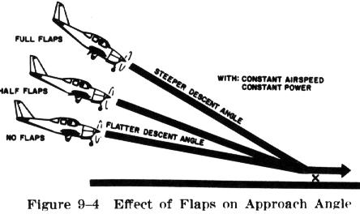

Flaps and the landing point:
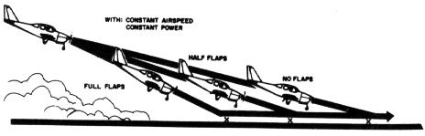

- ELO 2: Identify common errors in short field approaches and landing.

  - Improper use of performance data and limitations.

  - Failure to establish the approach or landing configuration at the appropriate time or in the proper sequence.

  - Failure to establish and maintain a stabilized approach.

  - Improper technique in use of power, flaps and trim.

  - Inappropriate removal of hand from throttle.

  - Improper techniques during roundout and touchdown.

  - Poor directional control after touchdown.

  - Improper use of brakes.

- ELO 3: Perform a short field landing.

  - Align the airplane with the runway. Make sure the plane is on the centerline.

  - Use either technique to correct for the crosswind. Stay lined up with the centerline.

  - Ensure correct flaps, power and gear settings. (Normally full flaps)

  - Maintain correction through the roundout point.

  - Begin the roundout. Make sure the wing in the crosswind is down.

  - Touchdown main wheels first. Hold the nose off the ground until it is ready to touch down. IT IS OK TO HEAR THE STALL WARNING HORN HERE.

  - Cut any remaining power.

  - Retract flaps.

  - Maximum braking without skidding tires.

  - Keep the nose up as long as you can.

  - Clear the runway when able. Complete the after landing check list.

