OBJECTIVE: To develop the student's accuracy, judgment, planning, technique, and confidence when little or no power is available in an emergency approach and landing.

ELEMENTS:

- Prompt establishment of the best glide airspeed and the recommended configuration.
- How to select a suitable emergency landing area.
- Planning and execution of approach to the selected landing area.
- Use of emergency checklist.
- Importance of attempting to determine reason for the malfunction.
- Importance of dividing attention between flying the approach and accomplishing emergency checklist.
- Techniques that can be used to compensate for undershooting or overshooting selected emergency landing area.

SCHEDULE: Pre-flight instruction: 10 Minutes
Travel to training area: 10 Minutes
Instructor Demonstration: 10 Minutes
Student Practice: 20 Minutes
Return from practice area: 10 minutes
Post-flight Review: 10 Minutes
Total Time: 1:10

EQUIPMENT: Functional aircraft.

INSTRUCTOR’S ACTIONS:
- Conduct preflight training on the elements of an emergency approach.
- Demonstrate emergency approach
- Conduct post flight briefing.

STUDENT’S ACTIONS:
- Ask questions, review homework.
- Perform preflight.
- Observe demonstrations.
- Perform IAW PTS.

COMPLETION STANDARDS: Student performs Emergency Approach IAW the PTS.

COMMON ERRORS:
- Failure to maintain Best Glide Speed.
- Improper airplane configuration.

Introduction: To develop the student's accuracy, judgment, planning, technique, and confidence in an emergency descent.

- Lesson Requirements:

  - Task: Perform an emergency approach and landing.

  - Condition: Given a functional aircraft.

  - Standard: IAW the PTS.

    - Exhibits knowledge of the elements related to emergency approach and landing procedures.
    - Analyzes the situation and selects an appropriate course of action.
    - Establishes and maintains the recommended best-glide airspeed, ±10 knots.
    - Selects a suitable landing area.
    - Plans and follows a flight pattern to the selected landing area considering altitude, wind, terrain, and obstructions.
    - Prepares for landing, or go-around, as specified by the examiner.
    - Follows the appropriate checklist.

- ELO 1: Identify the most important elements of an emergency approach.

  - FLY THE PLANE.

  - Best glide speed.

  - Identify landing area.

  - Student check

What is the best glide speed in this airplane? _______

- ELO 2: Identify common errors in the emergency approach.

  - Failure to maintain best glide speed. Pitch for airspeed, this is especially critical when you have no power.

  - Failure to reach the landing area. Pick a better landing area, fly the plane. You may have to adjust your speed, but don’t stall.

  - Failure to use the checklists. Once you have the plane under control, start troubleshooting.

- ELO 3: Perform an emergency approach.

  - Get best glide speed.

  - Identify landing area, begin moving toward it.

  - Troubleshoot. (fuel on correct tank, fullest or both; boost pumps on, mixture rich, carb heat on, flaps up, gear up).

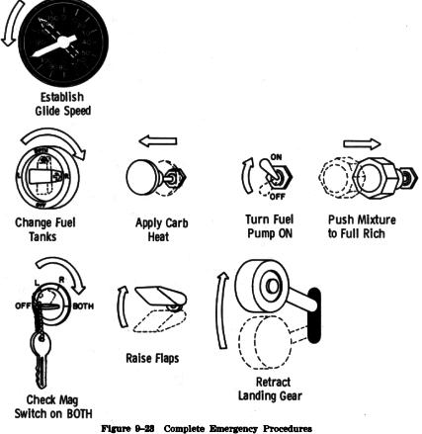

  - 7700 on transponder, notify ATC (121.5 or current ATC freq)

  - Set up for landing.

  - Extend gear and flaps when landing assured. (Examiner may end here)

  - Prior to landing open doors.

  - Land.

