OBJECTIVE: To conduct a normal or crosswind landing.

ELEMENTS:

- Situations where a go-around is necessary.
- Importance of making a prompt decision.
- Importance of applying takeoff power immediately after the go-around decision is made.
- Importance of establishing proper pitch attitude.
- Wing flaps retraction.
- Use of trim.
- Landing gear retraction.
- Proper climb speed.
- Proper track and obstruction clearance.
- Use of checklist.

SCHEDULE: Pre-flight instruction: 10 Minutes
Travel to training area: 10 Minutes
Instructor Demonstration: 10 Minutes
Student Practice: 30 Minutes
Return from practice area: 10 minutes
Post-flight Review: 10 Minutes
Total Time: 1:20

EQUIPMENT: Functional aircraft.

INSTRUCTOR’S ACTIONS:
- Conduct preflight training on the elements of a go around.
- Demonstrate a go around
- Conduct post flight briefing.

STUDENT’S ACTIONS:
- Ask questions, review homework.
- Perform preflight.
- Observe demonstrations.
- Perform go around IAW PTS.

COMPLETION STANDARDS: Student performs go around IAW the PTS.

COMMON ERRORS:

- Failure to recognize a situation where a go around is necessary or delaying initiating a go-around.
- Improper power application.
- Failure to control pitch attitude, compensate for torque or retrim.
- Failure to maintain recommended airspeeds.
- Improper wing flaps or landing gear retraction procedures.
- Failure to maintain proper track during climb-out and remain well clear of obstructions and other traffic.

Introduction: Sometimes even though we are set up for a landing, something happens that would cause us to reject the landing. The rejected landing is called a go around. The most important thing here is to get the plane back into the air quickly and safely. You need full power and a clean plane to climb back to the traffic pattern and either go to an alternate landing airport or to try to re-land.

- Lesson Requirements:

  - Task: Perform a normal or crosswind landing.

  - Condition: Given a functional aircraft.

  - Standard: IAW the PTS.

    - Exhibits knowledge of the elements related to a go-around/rejected landing.
    - Makes a timely decision to discontinue the approach to landing.
    - Applies takeoff power immediately and transitions to climb pitch attitude for VY, and maintains VY+10/-5 knots.
    - Retracts the flaps as appropriate.
    - Retracts the landing gear, if appropriate, after a positive rate of climb is established.
    - Maneuvers to the side of the runway/landing area to clear and avoid conflicting traffic.
    - Maintains takeoff power VY +10/-5 to a safe maneuvering altitude.
    - Maintains directional control and proper wind-drift correction throughout the climb.
    - Completes the appropriate checklist.

- ELO 1: What would cause a rejected landing?

  - Anything that would make you feel that the landing under the current circumstances unsafe or make you uncomfortable.

  - Student Check:

Name three things that could cause an aborted landing?
When is an aborted landing most dangerous?

- ELO 2: Identify common errors in approaches and landing.

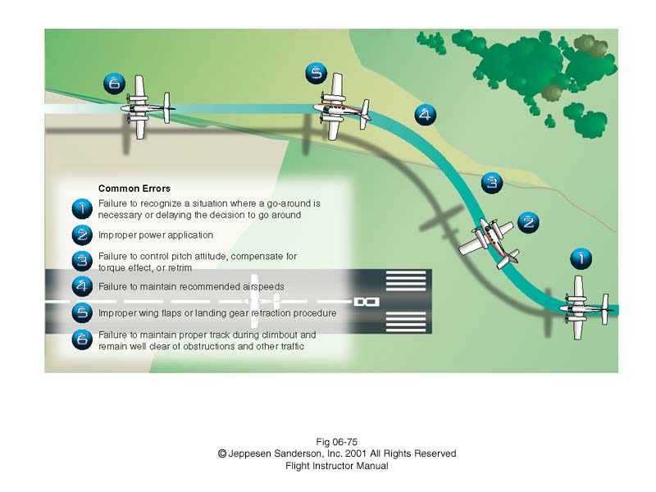
- ELO 3: Perform a go around. ALWAYS FLY THE AIRPLANE FIRST!!!

  - Full power.

  - Pitch up slightly to descent.

  - Partially retract flaps to reduce drag.

  - Trim as required.

  - Retract landing gear at PROC.

  - Accelerate to Vy.

  - Retract flaps.

  - Contact the tower.

  - Follow the tower’s instructions.

