OBJECTIVE: To conduct a normal or crosswind landing.

ELEMENTS:

- How to determine landing performance and limitations.
- Configuration, power, and trim.
- Obstructions and other hazards which should be considered.
- A stabilized approach at the recommended airspeed to the selected touchdown area.
- Coordination of flight controls.
- A precise ground track.
- Wind shear and wake turbulence.
- Most suitable crosswind technique.
- Timing, judgment, and control technique during roundout and touchdown.
- Directional control after touchdown.
- Use of brakes.
- Use of checklist.

SCHEDULE: Pre-flight instruction: 10 Minutes
Travel to training area: 10 Minutes
Instructor Demonstration: 10 Minutes
Student Practice: 30 Minutes
Return from practice area: 10 minutes
Post-flight Review: 10 Minutes
Total Time: 1:20

EQUIPMENT: Functional aircraft.

INSTRUCTOR’S ACTIONS:
- Conduct preflight training on the elements of a normal or crosswind landing.
- Demonstrate normal and crosswind landing.
- Conduct post flight briefing.

STUDENT’S ACTIONS:
- Ask questions, review homework.
- Perform preflight.
- Observe demonstrations.
- Perform landing IAW PTS.

COMPLETION STANDARD: Student performs each landing IAW the PTS.

COMMON ERRORS:
- Failure to establish the approach or landing configuration at the appropriate time or in the proper sequence.
- Failure to establish and maintain a stabilized approach.
- Faulty technique during roundout and flare.
- Poor directional control during rollout.

Introduction: Just as a successful takeoff is required for any flight, so must there be a successful landing. Most people will remember the landing more than the rest of the flight. It doesn’t matter how smooth the takeoff was and how uneventful the flight was, if the landing is poor, then the flight is poor. No two landings are ever the same. There is always something different about each landing. The trick is to have a baseline, recognize what has changed and adjust from there. This is where a stabilized approach comes in.

- Lesson Requirements:

  - Task: Perform a normal or crosswind landing.

  - Condition: Given a functional aircraft.

  - Standard: IAW the PTS.

    - Exhibits knowledge of the elements related to a normal and crosswind approach and landing.
    - 2. Adequately surveys the intended landing area (ASES).
    - 3. Considers the wind conditions, landing surface, obstructions, and selects a suitable touchdown point.
    - 4. Establishes the recommended approach and landing configuration and airspeed, and adjusts pitch attitude and power as required.
    - 5. Maintains a stabilized approach and recommended airspeed, or in its absence, not more than 1.3 VSO, +10/-5 knots, with wind gust factor applied.
    - 6. Makes smooth, timely, and correct control application during the roundout and touchdown.
    - 7. Contacts the water at the proper pitch attitude (ASES).
    - 8. Touches down smoothly at approximate stalling speed (ASEL).
    - 9. Touches down at or within 400 feet (120 meters) beyond a specified point, with no drift, and with the airplane's longitudinal axis aligned with and over the runway center/landing path.
    - 10. Maintains crosswind correction and directional control throughout the approach and landing sequence.
    - 11. Completes the appropriate checklist.

- ELO 1: Understand the concept of a stabilized approach.

  - What is a stabilized approach? It is an approach that essentially requires very little control input to land the plane. This means you are at the correct flap settings (usually full, but adjustments can be made based on conditions), gear position, airspeed (1.3VsO) and pitch attitude until you are ready to land the airplane. The idea is that you are not making any major adjustments once you are established on final.

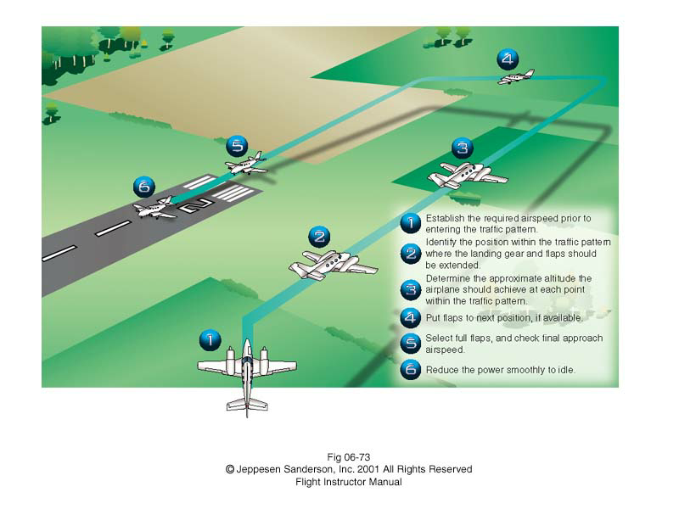
Figure 1: Stabilized Approach

  - Student Check:

What is the approach speed for this airplane? _______
What is the correct flap setting for this airplane on final? ______

- ELO 2: Adjust the approach for crosswind.

  - What effect will a crosswind have on an approach? Just like any other time the airplane is in the air, the crosswind will push the airplane to one side of the runway.

  - How do you correct the drifting tendency of the crosswind? There are two techniques. We will practice both of them. The first technique is a simple crab. Crab the airplane like you normally would for normal flight. The second method is to do the wing low method.

  - Crab method.

        - Crab like you normally would for flying.

        - Maintain the crab until just before landing.

        - Then kick in the appropriate rudder and lower the upwind wing. (wing low method).

        - Land with one wing slightly lower than the other.

        - This method requires good timing to ensure the plane does not drift sideways just prior to landing.

  - Wing low method.

        - Place the upwind wing down.

        - Maintain directional control with the rudder.

        - You will be cross controlled, this is ok. Maintain airspeed.

        - Maintain this posture until you land.

- ELO 3: Identify the round out point.

  - What is the round out point? The round out point is that point at which you will stop the descent of the airplane and begin the transition to flare and land the airplane.

  - What is the benefit of the round out point? The round out point will allow you to land almost exactly where you want to every time.

  - How do I pick out the round out point? Pick a point some distance before your desired touchdown point. (Try a couple hundred feet for a Cessna 172). Take care to pick a point close enough that you don’t land short. Once you pick out that, keep it in the same spot in your windshield. Pitch for airspeed, power for altitude. Fly to it. When you reach the round out point, stop the descent by pulling back gently on the yoke. Keep applying back pressure to complete the flare and touch down.

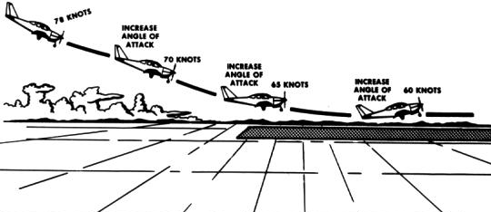
Figure 2: Roundout and Flare

- ELO 4: Identify common errors in approaches and landing.

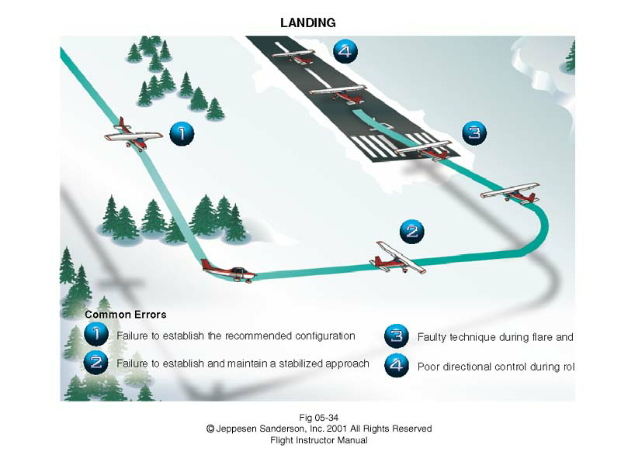
Figure 3: Common Errors in Landing

- ELO 5: Perform a normal or crosswind landing.

  - Align the airplane with the runway. Make sure the plane is on the centerline.

  - Use either technique to correct for the crosswind. Stay lined up with the centerline.

  - Ensure correct flaps, power and gear settings.

  - Maintain correction through the roundout point.

  - Begin the roundout. Make sure the wing in the crosswind is down.

  - Idle power.

  - Touchdown main wheels first. Hold the nose off the ground until it is ready to touch down. IT IS OK TO HEAR THE STALL WARNING HORN HERE.

  - Apply the minimum required braking power. As the airspeed drops, pulling back on the yoke will help slow the airplane.

  - Clear the runway when able. Complete the after landing check list.

