OBJECTIVE: To develop division of attention between flight and ground paths while controlling the aircraft and scanning for traffic; develop recognition of drift; and continue to develop smoothness, coordination, and orientation.

ELEMENTS:

- How to select a suitable altitude.
- How to select a suitable ground reference with suitable emergency landing areas.
- Orientation, division of attention, and planning.
- Configuration and airspeed prior to entry.
- Relationship of a rectangular course to an airport traffic pattern.
- Wind drift correction.
- How to maintain desired altitude, airspeed, and distance from ground reference boundaries.
- Timing of turn entries and rollouts.
- Coordination of flight controls.

SCHEDULE: Pre-flight instruction: 10 Minutes
Travel to training area: 10 Minutes
Instructor Demonstration: 10 Minutes
Student Practice: 20 Minutes
Return from practice area: 10 minutes
Post-flight Review: 10 Minutes
Total Time: 1:10

EQUIPMENT: Functional aircraft.

INSTRUCTOR’S ACTIONS:
- Conduct preflight training on the elements of S Turns.
- Demonstrate the rectangular course.
- Conduct post flight briefing.

STUDENT’S ACTIONS:
- Ask questions, review homework.
- Perform preflight.
- Observe demonstrations.
- Perform IAW PTS.

COMPLETION STANDARDS: Student performs the rectangular course IAW the PTS.

COMMON ERRORS:
- Entering the maneuver improperly.
- Improper judging wind direction and speed.
- Uncoordinated turns.
- Failure to maintain selected altitude or airspeed.
- Improper wind drift correction.

Introduction: The traffic pattern is really a large rectangular course. Flying this course properly requires that we adjust for the prevailing wind. Not only do you have to adjust the angle of bank, but you also have to adjust the crab angle to fly straight. Doing this correctly will ensure that you can fly a correct traffic pattern and will help to ensure that you line up with the runway correctly just about every time.

- Lesson Requirements:

  - Task: Perform a rectangular course.

  - Condition: Given a functional aircraft.

  - Standard: IAW the PTS.

    - Exhibits knowledge of the elements related to a rectangular course.
    - Selects a suitable reference area.
    - Plans the maneuver so as to enter a left or right pattern, 600 to
    - 1,000 feet AGL (180 to 300 meters) at an appropriate distance from the selected reference area, 45° to the downwind leg.
    - Applies adequate wind-drift correction during straight-and-turning flight to maintain a constant ground track around the rectangular reference area.
    - Divides attention between airplane control and the ground track while maintaining coordinated flight.
    - Maintains altitude, ±100 feet (30 meters); maintains airspeed, ±10 knots.

- ELO 1: Understand the effects of wind on a flying airplane.

  - The air is more like the ocean than a solid mass. As the wind blows it will tend to push an airplane in the direction of airflow. This is just like an boat in a river as it flows in the direction of the stream. Pilots compensate for this by adjusting the crab angle in straight slight, and by adjusting the angle of bank in turns.

  - How do winds affect groundspeed? Moving downwind (with the wind) causes the airplane to have an increase in groundspeed. Moving upwind (against the wind) causes the airplane to have a decrease in groundspeed. In both cases the airspeed indicator may read the same.

  - How do winds affect the angle of bank and rate of turn? When traveling on the downwind side of the turn the airplane tends to increase speed and a greater rate of turn must be used to compensate for the increased airspeed. On the upwind side of the turn, the bank will be shallower because the airplane is moving slower.

  - How does wind affect the ground track of an aircraft flying perpendicular to it? The wind pushes the airplane sideways in the direction of the wind.

  - Student Check:

What is the effect of the wind when turning into the wind?
What is the effect of the wind when turning away from the wind?

- ELO 2: Identify common errors in the rectangular courses.

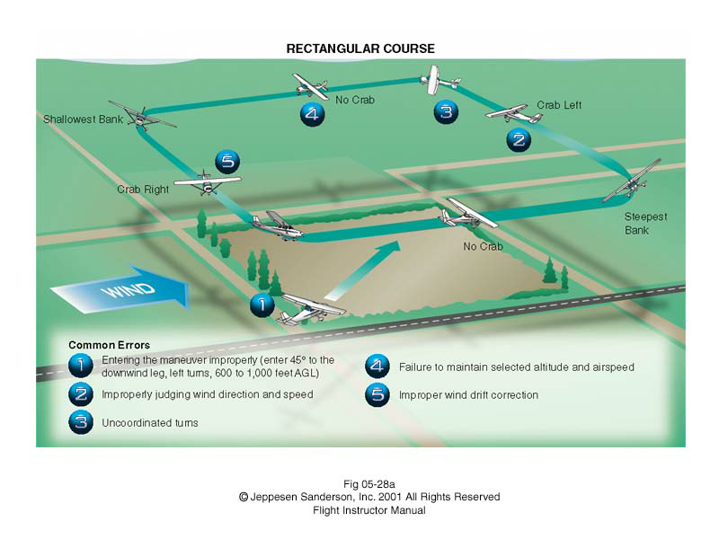
- ELO 3: Perform maneuvers around a rectangular course.

  - Pick an appropriate entry altitude (600-1000 ft agl).

  - Select your rectangular course. The course should be visible from both pilots’ points of view.

  - Enter the maneuver WITH the wind and parallel to one of the sides of the course.

  - Plan your turn to maintain the same distance from all the sides of the rectangle.

  - Begin the turn abeam the corner. You will roll out at the proper crab angle. (This may mean a more than a 90 degree turn depending on where you are in the sequence.)

  - Maintain the crab into the wind when you fly perpendicular to the wind.

  - Plan the next turn to keep the same distance from the next side.

  - Remember this is putting together multiple turns around a point, you are just breaking the turns up with some periods of “straight” flight. This also replicates how you will fly the traffic pattern around an airport.

  - Continue the maneuver until told to stop.

