OBJECTIVE: To conduct a correct soft field landing.

ELEMENTS:

- How to determine landing performance and limitations.
- Configuration and trim.
- Obstructions and other hazards which should be considered.
- Effect of wind and landing surface.
- Selection of a touchdown area.
- A. stabilized approach at the recommended airspeed to the selected touchdown area.
- Coordination of flight controls.
- A precise ground track.
- Timing, judgment, and control technique during roundout and touchdown.
- Touchdown in a nose-high pitch attitude at minimum safe airspeed.
- Proper use of power.
- Directional control after touchdown.
- Use of checklist.

ASSOCIATED MANEUVERS:

SCHEDULE: Pre-flight instruction: 10 Minutes
Travel to training area: 10 Minutes
Instructor Demonstration: 10 Minutes
Student Practice: 30 Minutes
Return from practice area: 10 minutes
Post-flight Review: 10 Minutes
Total Time: 1:20

EQUIPMENT: Functional aircraft.

INSTRUCTOR’S ACTIONS:
- Conduct preflight training on the elements of a soft field landing.
- Demonstrate soft field landing.
- Conduct post flight briefing.

STUDENT’S ACTIONS:
- Ask questions, review homework.
- Perform preflight.
- Observe demonstrations.
- Perform landing IAW PTS.

COMPLETION STANDARDS: Student performs each landing IAW the PTS.

COMMON ERRORS:
- Failure to establish the recommended configuration.
- Failure to establish and maintain a stabilized approach.
- Allowing the nose wheel to touchdown too soon after main wheels.
- Poor directional control.
Introduction: In a soft field landing you will attempt to keep the weight of the airplane on the wings as long as possible. This approach is generally done with a little more power than a normal approach. This means touchdown will be at a slightly higher airspeed. You will also use far less braking power. Remember you don’t want to get stuck in the mud or slush here. The examiner could ask you to do a soft field approach and landing with an obstacle present. Treat the approach like a short field approach, but perform the landing like a soft field landing.

- Lesson Requirements:

  - Task: Perform a soft field landing.

  - Condition: Given a functional aircraft.

  - Standard: IAW the PTS.

    - Exhibits knowledge of the elements related to a soft-field approach and landing.
    - Considers the wind conditions, landing surface and obstructions, and selects the most suitable touchdown area.
    - Establishes the recommended approach and landing configuration, and airspeed; adjusts pitch attitude and power as required.
    - Maintains a stabilized approach and recommended airspeed, or in its absence not more than 1.3 VSO, +10/-5 knots, with wind gust factor applied.
    - Makes smooth, timely, and correct control application during the roundout and touchdown.
    - Touches down softly with no drift, and with the airplane's longitudinal axis aligned with the runway/landing path.
    - Maintains crosswind correction and directional control throughout the approach and landing sequence.
    - Maintains proper position of the flight controls and sufficient speed to taxi on the soft surface.
    - Completes the appropriate checklist.

- ELO 1: Understand the aircraft configuration.

  - What is the configuration for landing and approach? The configuration is the same as a normal approach. The difference is in the actual landing not the approach.

  - Student Check:

What is the approach speed for this airplane? _______
What is the correct flap setting for this airplane on final? ______

- ELO 2: Identify common errors in soft field approaches and landing.

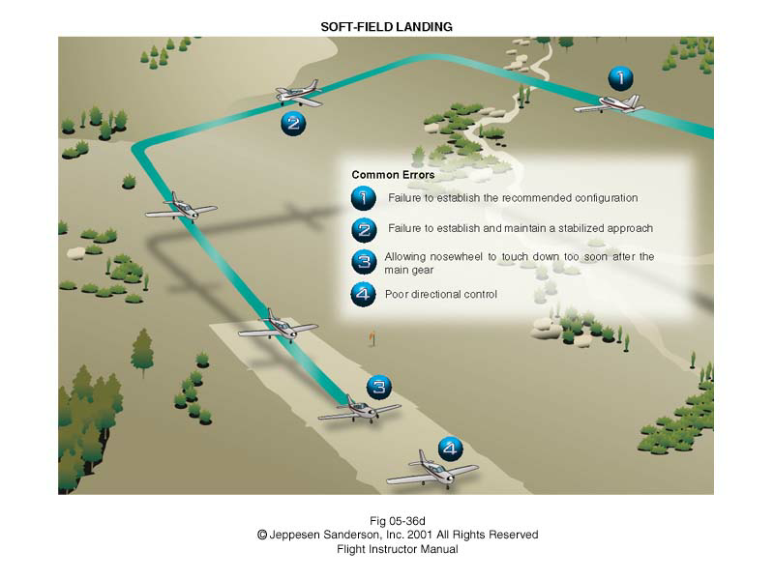
- ELO 3: Perform a soft field landing.

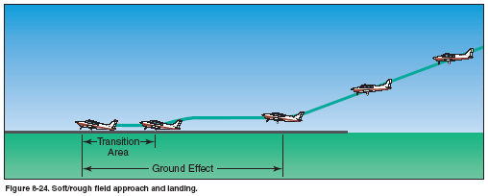

  - Align the airplane with the runway. Make sure the plane is on the centerline.

  - Use either technique to correct for the crosswind. Stay lined up with the centerline.

  - Ensure correct flaps, power and gear settings. (Normally full flaps)

  - Maintain correction through the round out point.

  - Begin the round out. Make sure the wing in the crosswind is down. You will need just a little more power than normal here. That is ok. (Technique – Idle power and then add enough to hear engine noise change).

  - Touchdown main wheels first. Hold the nose off the ground until it is ready to touch down. IT IS OK TO HEAR THE STALL WARNING HORN HERE.

  - DO NOT APPLY BRAKES!!!! Brakes may cause you to increase the load on the wheels and then they could get stuck in the mud or slush. Keep back pressure on the elevator. Let the nose fall only when it is ready.

  - Clear the runway when able. Complete the after landing check list.

